Tracy Michaels

002430918

System Level Programming Lab 6 Part 2

Part A

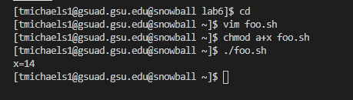

* Initializes variables x to 0 and I to 1
* Steps into while loop that will iterate as long as variable i is less than or equal to 3; currently i is 1 so it steps into loop
* Initializes variable s to i \* i
  + s = 1
* Assigns variable x to the sum of variable s and x (1 + 0)
  + x = 1
* Increments i by one
  + i = 2
* Returns to while loop check
* Enters while loop since i is less than or equal to 3
* Assigns variable s to the i squared (2 \* 2)
  + s = 4
* assigns variable x to the sum of s and x (4 + 1)
  + x = 5
* increments i by one
  + i = 3
* returns to while loop check
* enters while loop since i is less than or equal to 3
* assigns variable s to the square of i (3 \* 3)
  + s = 9
* assigns variable x to the sum of s and x (5 + 9)
  + x = 14
* increments i by one
* returns to while loop check
* doesn’t enter while loop because i is greater than 3
* prints contents of x which is 14

Part B



Part C

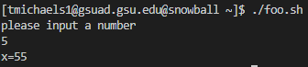

Part D

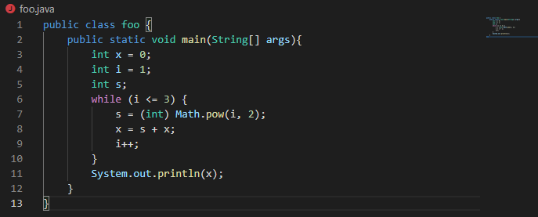

Part E

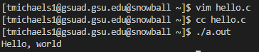

2) a file called ‘hello’ is created

3)



4)

